**Release 2**

**CHUBB Overseas General Insurance[COG]**

**ASPAC Test Approach**

Version : 1.1

Date : 26 Apr 2016

Produced By : COG QEA Team

**R2 COG ASPAC Test Approach: Signoff**

This document requires the following approvals.

| **Name** | **Role** | **Approval Status** | **Date** |
| --- | --- | --- | --- |
| Neil Collis | AVP, Strategic Programmes |  |  |
| Kevin Larison | IT Project Manager |  |  |
| Robert Brauer | Enterprise Application Architect |  |  |
| Ollie Ferreira | IT Business Archetect |  |  |

**Distribution List:**

|  |  |  |
| --- | --- | --- |
| **Name** | **Summary** | **Review Date** |
| Neil Collis | AVP, Strategic Programmes |  |
| Kevin Larison | IT Project Manager |  |
| Robert Brauer | Enterprise Application Architect |  |
| Ollie Ferreira | IT Business Archetect |  |
| Aravind Ravichandar | Test Manager |  |

**Change Control Log - Revision History:**

|  |  |  |  |
| --- | --- | --- | --- |
| **Date** | **Summary** | **Version** | **Author** |
| 18th Apr 2016 | R2 Work View COG ASPAC Test Approach | 1.0 | QEA Team |
| 22nd Apr 2016 | Test Approach is updated with the preliminary review comments | 1.1 | QEA Team |
|  |  |  |  |
|  |  |  |  |
|  |  |  |  |

Table of Contents

1 Introduction 6

1.1 Purpose 6

1.2 Project Background 6

2 Test Objectives 8

3 Test Scope 9

3.1 In Scope 9

3.2 Out of Scope 12

4 Test Approach 13

4.1 Test Initiation / Test Strategy 14

4.2 Requirement Analysis / Test Planning 14

4.3 Test Design 15

4.4 Test Execution 16

4.5 Test Closure 17

5 Test Components / Functionalities 18

5.1 Work View COG: 18

5.2 Overall Estimated Test Cases Count for ASPAC: 18

6 Leveraging From ASPAC & NA 20

6.1 Test Design 20

6.2 Test Execution 20

7 Test Methodology 21

7.1 Smoke Testing 21

7.2 System Integration Testing 21

7.3 End to End Testing 29

7.4 Regression Testing 29

7.5 Automation Testing 30

8 Test Plan 31

9 Quality Gates 33

10 Test Tools 34

11 Defect Management 35

11.1 Defect Life Cycle 35

11.2 Defect Triage 36

11.3 Defect Classifications 36

11.4 Defect Business Severity 37

11.5 Defect Fix Priority 37

12 Test Data 38

13 Test Metrics 39

14 Test Environments 40

15 Test Deliverables 41

16 Test Criteria 42

16.1 Test Entry / Exit Criteria 42

16.2 Test Suspension / Resumption 42

16.3 Test Assumptions / Dependencies 43

17 Roles & Responsibilities 44

18 RACI Matrix 45

19 Reference Documents 46

# Introduction

## Purpose

The purpose of this document is to define the overall test approach for the **Work View COG ASPAC** **Release 2** for CHUBB Insurance. The test approach defines the scope of the test stage enabling a common understanding of the are as that will be tested, and the processes that will be followed for test preparation and execution, test management, types of testing, test environments used, change & defect management and entry & exit criteria for each phase.

The purpose of test approach is to:

1. Define how the appropriate testing principles and practices will be applied in order to manage testing risks and identify issues in quality
2. Define scope of testing to enable development of test conditions, test cases and test plans to be produced
3. Provide a common platform to be followed for testing across multiple organizational structures and business units
4. Provide a direction for the testing activities to be carried out with the workflows
5. Serve as a communication vehicle to identify any testing issue early in the project lifecycle

It also acts as a document of understanding regarding testing between the testing team, project management team and stakeholders of the project.

## Project Background

The Apollo Refresh Program has been commissioned to replace Apollo’s current ageing architecture with a CHUBB strategic Enterprise Case Management (ECM) solution, Work View. This will provide all of the existing functionality with opportunities for process consistency and an enabler for operational and technology efficiency.

Release 2 of the Apollo Refresh Program will add functionality for Claims, Policy and Customer Services processing to the Work View platform for the CHUBB Overseas General (COG) Region (Asia Pacific – ASPAC).

**Work View COG ASPAC Program – Landscape**

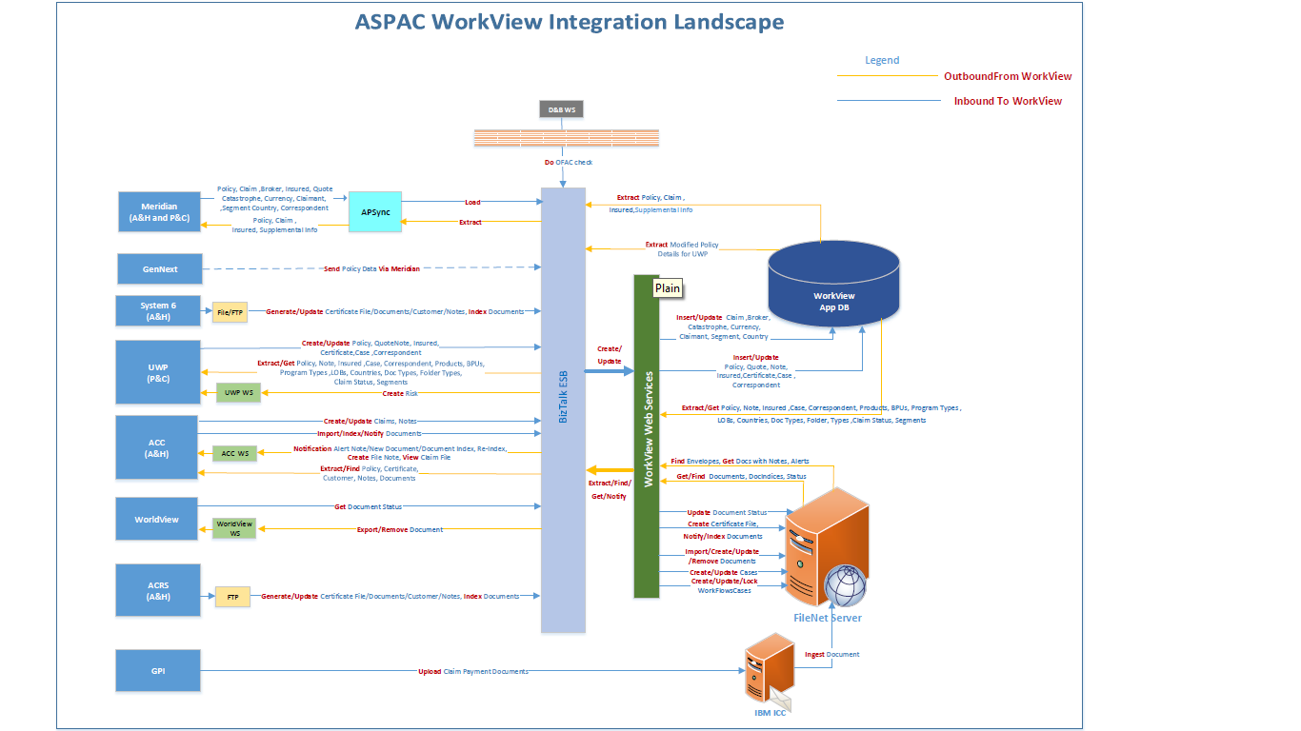

# Test Objectives

The key objectives of testing are:

* **Verify that the solution meets the business requirements** so that the system can be used effectively in the target environment. The application's support of business needs is addressed by formally testing the functionality, operations, procedures and performance of the application.
* **Ensure operational reliability** by uncovering defects in the system early on and fixing them. This includes locating logic errors and other defects that may cause the system to be unreliable.

COG ASPAC R2 Testing is to ensure that the constituent components of the system will operate and communicate with each other as designed; ensuring that both the functional and non-functional behaviors are working as expected and the end-to-end systems are stable. Testing will include both ‘end to end’ testing of data flows across the **WorkView components, and Interface testing for 7 Interfaces**, which will prove communications between systems are still working effectively. It will ultimately demonstrate that any newly added functionality is working, and that pre-existing functionality is still working.

The above Testing objectives are achieved through -

|  |  |
| --- | --- |
| **Test Objective** | **Achieved by** |
| Verify the quality of code is good enough to test in SIT environment | Sanity / Smoke Testing |
| Verify the functionalities of individual components with respect to business requirements | System Testing |
| Verify the functionalities and the communication between integrated systems | System Integration Testing |
| Verify the end to end system business workflow is fit for business purpose | End to End Testing |
| Verify that existing business processes have not been negatively impacted after each build | Regression Testing |

# Test Scope

## In Scope

The test in-scope for ASPAC region:

* Singapore country is covered for ASPAC Release 2 Drop1 Testing.
* The below mentioned interfaces are in-scope for the Integration Testing

1. Meridian
2. UWP
3. ACC
4. System6
5. ACRS
6. Gen Next
7. CHUBB OFAC sanctions

* COG Underwriting Updates: Policy and Policy Subsequent Transaction integration to WorkView from the Underwriting Interface Systems such as Meridian, UWP, Gen Next, ACRS and System6.
* COG Claims Updates: Claims and Claim Subsequent Transaction integration to Work View from the Claim Administration Interface Systems such as Meridian and ACC
* COG Workflow: COG specific workflows upon different Insurance process such as Underwriting, Claim, Customer Interaction, Complaints and BIRI etc.
* Core: Reuse the Core Work view ASPAC/NA Functionalities for Document and workflow management.
  + 1. **COG ASPAC Workflow - High Level Overview:**

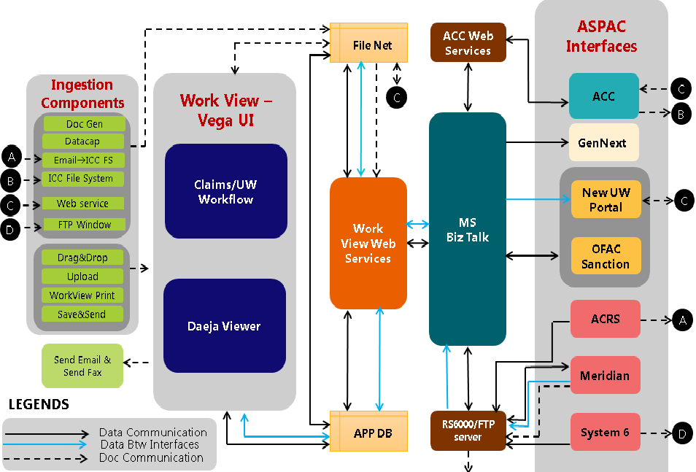

* + 1. **COG ASPAC R2 Testing In scope Components:**

|  |  |  |
| --- | --- | --- |
| **Category** | **Component** | **Functionalities** |
| COG ASPAC Interfaces | Interface Integration | ACC Integration |
| Meridian Integration |
| ACRS Integration |
| System6 Integration |
| UWP Integration |
| Chubb OFAC Sanction |
| Gen Next |

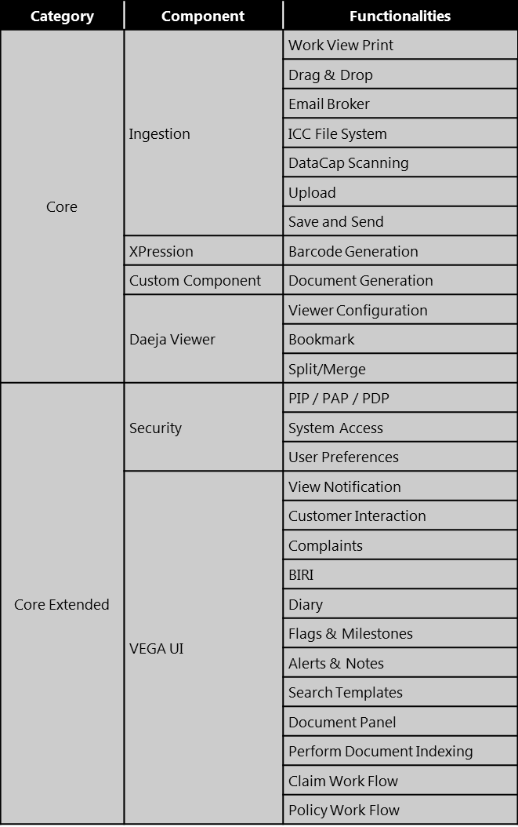

**Note:** Interface Vs WorkView Workflow test matrix is attached below



* + 1. **Pre-Requisite**
* Signed off requirements are to be shared to complete the test design.
* The Business Process Flow diagram between Interfaces and WorkView is required to come up with End-to-End Business Scenarios.
* Field Mapping document between Interfaces and Work View is required for test design
* Requirement Traceability Matrix between Functional Spec Document and Region specific requirement documents is required to proceed with the Test Design.
* SIT Environment should be available with the interfaces connected to WorkView at the agreed Time Lines to commence and complete the SIT test execution within agreed Time Line

## Out of Scope

* The following types of testing will be out of scope for SIT:
  + - * Unit Testing
      * Multi-Lingual Testing
      * User Acceptance Testing
      * Disaster Recovery Testing
* Data Migration and Performance Testing will be covered in a separate Test Strategy
* The changes in Interface System Field/ Architecture/Process will not be part of WorkView Integration Testing.
* Testing will not be carried out for the Source/Targeted System, which is integrated to WorkView. The respective interface testing team is responsible to test the interface functionality.
* The End-to-End Business flow testing will not be carried for the systems that are not directly linked with WorkView. The respective system testing team is responsible to test the system and its direct connectivity.

# Test Approach

This section describes the testing approach that would list the various test phases, techniques and tools used for the same. The tools and processes used for the test phases would also be listed as part of the approach.

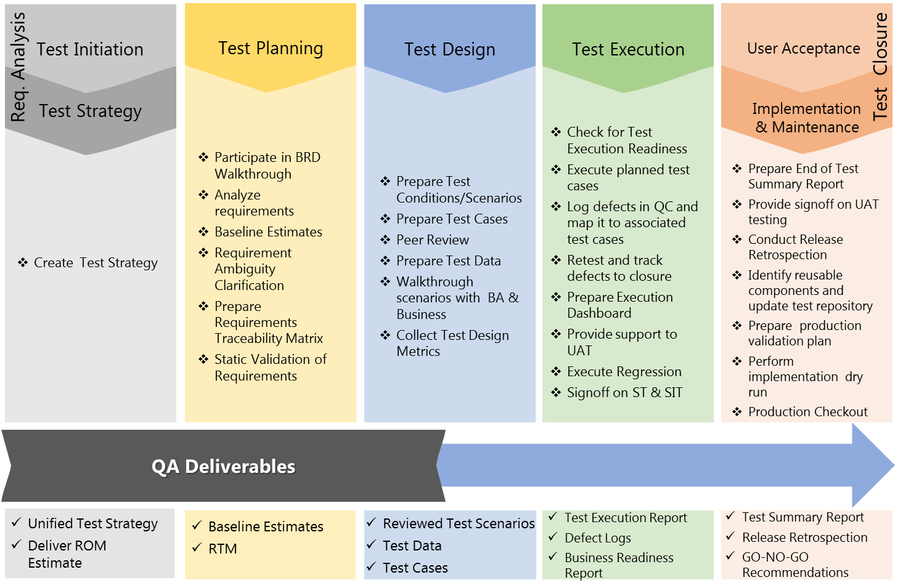

The Testing of Work View COG application will contain the following five-phased approach for testing:

* Test Initiation / Test Strategy
* Test Planning
* Test Design
* Test Execution
* Test Closure

## Test Initiation / Test Strategy

The testing team would outline the high-level overview of the entire testing timeline based on the development build plans for SIT drops. The testing team will also define the test approach to describe the plan for testing activities, test scope, test process, test deliverables, test completion criteria, test prioritization, tools support, resourcing, and responsibility matrix.

## Requirement Analysis / Test Planning

**4.1.1 Requirement Analysis**

The testing team would work with the Requirements team and Business analysts to understand the overall system architecture and testing requirements. The team will understand the new components i.e. Customer Interaction, BIRI, Complaints, Policy Workflow, Claim Workflow and Interface, which is defined Functional specification/Config/Other related documents. The project documents available in CHUBB SharePoint (Business requirements, functional specifications, Use Case documents for CORE components, configuration documents, etc.) will be used for the study, to accurately understand and analyze the requirements for testing. The testing team will also work on collating the testing artifacts such as requirement ambiguities tracker, requirement clarifications tracker and requirement Traceability matrix. These interactions and artifacts will form the base from which the testable requirements will be harvested to formulate a test plan.

**4.1.2 Test Planning**

The testing team will work with test coordinators to develop a test plan that will be applicable across different types of testing that would be conducted under Work View project. Key activities such as effort estimation and resource loading required for the Work View COG project are performed. The testing approach and scope for each type of testing is determined. All potential risks and mitigation plans are identified during the test-planning phase.

|  |  |  |  |
| --- | --- | --- | --- |
| ENTRY CRITERIA | TASK | EXIT CRITERIA | DELIVERABLE |
| 1. Requirements (BRD, SAS, and Functional Specification and Configuration sheet) base-lined and signed off by the Business 2. Availability of SMEs and BAs for Requirements walk through 3. Scope base-lined & signed off 4. Testing approach finalized 5. Risks, Issues and actions identified | 1. Requirement Gathering and analysis 2. Queries and Prioritization 3. Pre-requisite Identification 4. Phase-wise Test Criteria definition | 1. All outstanding queries from KT Phase are resolved 2. High & Medium priority queries resolved 3. Test Strategy signed off by the signatories | 1. Test Strategy Document 2. Query Tracker |
|
|
|
|
|

## Test Design

This phase will dwell on identification of test scenarios, construction of test cases and test data. For each functional requirement, the testing team will identify one or more test scenarios, and for each scenario, one or more test cases, and for each test case, corresponding test data is created. The test cases would also be mapped to the requirements for Traceability. The test design artefacts will be reviewed with IT BA for business confirmation and sign-off.

|  |  |  |  |
| --- | --- | --- | --- |
| ENTRY CRITERIA | TASK | EXIT CRITERIA | DELIVERABLE |
| 1. All outstanding queries need to be resolved 2. Signed off Requirement is to be available 3. Availability of BA and Dev support 4. Project Set Up in QC and access available | 1. Test scenario and test case creation 2. Test Data manipulation / preparation 3. Test case upload and establish Traceability Matrix | 1. Test Scenarios is to be reviewed by Business and Signed Off 2. Test Cases available in QC | 1. Detailed Test Cases 2. Traceability Matrix 3. Test Data |
|
|
|
|
|

## Test Execution

Once the test cases and test data are signed off, and the test environment is set up, the test cases would be executed in this phase. During this phase, the testing team will execute the test cases, document the test results, report and track defects to logical closure. Test Execution is carried out in two phases - Cycle 1 and Cycle 2. In Cycle 1, all test cases (100%) would be executed and the testing in Cycle 2 with 40% of test cases being executed with an assumption of 30% failure rate in Cycle 1 & 10% regression cases. System and System Integration test execution would utilize the Web Interface for testing. Fixes should only be deployed into the test environment with agreement from the Test Management Team

|  |  |  |  |
| --- | --- | --- | --- |
| ENTRY CRITERIA | TASK | EXIT CRITERIA | DELIVERABLE |
| 1. Integrated SIT Environment is to be available before Execution 2. Unit Testing is to be completed and Logs should be shared 3. Handshake Testing should be completed. | 1. Execute all test cases 2. Log Defect in QC 3. Defect Triaging and prioritization 4. Sanity testing on the Build deployment 5. Regression testing on the defects fixed 6. Defect Closure 7. Reporting | 1. Critical / High / Medium System defect are fixed and closed 2. Risk of any outstanding defects are understood and agreed to be tested in SIT 3. Sign off on the applications from the respective system test team | 1. Test Log 2. Test Summary report at the End of the Cycle |
|
|
|
|
|

**Desktop configurations for testing:**

|  |  |  |
| --- | --- | --- |
| **64 Bit Machine** | **IE9** | **IE11** |
| **Java 1.6** | Not Applicable | Partial |
| **Java 1.7** | Partial | Partial |
| **Java 1.8** | Fully | Fully |

|  |  |  |
| --- | --- | --- |
| **32 Bit Machine** | **IE9** | **IE11** |
| **Java 1.6** | Not Applicable | Not Applicable |
| **Java 1.7** | Not Applicable | Partial |
| **Java 1.8** | Not Applicable | Fully |

## Test Closure

At the end of a test execution cycle, the testing team would submit test summary results report summarizing the test execution status, defect severity and test execution coverage. Upon completion of all the testing cycles, the testing team will submit a test closure report, which will highlight the key metrics that can be used to determine the improvement opportunities and the quality of the application.

|  |  |  |  |
| --- | --- | --- | --- |
| ENTRY CRITERIA | TASK | EXIT CRITERIA | DELIVERABLE |
| 1. Critical / High / Medium System defect is fixed and closed | 1. Test Summary Report preparation 2. RCA preparation | 1. Test Summary Report completion and Approval from Business | 1. Test Summary Report |
|
|
|
|
|

# Test Components / Functionalities

## Work View COG:

<https://officespace.ace-ina.com/s/Apollo2Symposium/General/Forms/AllItems.aspx?RootFolder=%2Fs%2FApollo2Symposium%2FGeneral%2FApollo%20Refresh%20Program%2F07%5FRelease%5F2&View=%7B63698F83%2DC9C8%2D44F4%2DA5E9%2D560C9C24594E%7D>

## Overall Estimated Test Cases Count for ASPAC:

|  |  |  |
| --- | --- | --- |
| **Region** | **TCP Type** | **TCP Count** |
| Global | Functional | 3146 |
| ASPAC | Functional | 479 |
| Data Driven | 96 |
| E2E Interfaces (7) | 1200 |
| **Total ASPAC Test Case Count** | | **4921** |

The given test case count is based on the initial analysis done on the existing functional design documents, UI configuration documents. Individual test scenarios/scripts will not be listed in this document but will be held within the test management tool HP ALM 11.0 with the below alignment to achieve maximum reusability.

URL : <http://uk01dqct004:8080/qcbin/start_a.jsp>

Domain : AOG_GDC_DEVELOPMENT

Project : Apollo_Refresh_Global

Test Plan Path : Subject\Work View_Release 1_COG_SIT_QA Team

**Folder Structure Alignment:**

* Core: Reuse across the regions without any change.
* Core Extended: Update the test cases based on the region wise business rules / file properties.
* COG: Regional functionalities related to R2 COG ASPAC.

**SharePoint Link for Test Artefacts**

**Test Approach Document**

[http://europespace.acegroup.com/sites/AR_AOGRel3_Project/SitePages/Home.aspx?RootFolder=%2Fsites%2FAR%5FAOGRel3%5FProject%2FShared%20Documents%2F05%5FTest%2FTest%20Strategy&FolderCTID=0x012000A94F981F8FF08D40A56C72D5EAD2B984&View={53B4DA14-BE86-4765-BF10-40864446FE75}](http://europespace.acegroup.com/sites/AR_AOGRel3_Project/SitePages/Home.aspx?RootFolder=%2Fsites%2FAR%5FAOGRel3%5FProject%2FShared%20Documents%2F05%5FTest%2FTest%20Strategy&FolderCTID=0x012000A94F981F8FF08D40A56C72D5EAD2B984&View=%7b53B4DA14-BE86-4765-BF10-40864446FE75%7d)

**Test Scenario Documents**

[<<Yet](http://europespace.acegroup.com/sites/AR_CGM_Project/SitePages/Home.aspx?RootFolder=%2Fsites%2FAR%5FCGM%5FProject%2FShared%20Documents%2F05%5FTest%2F02%20Test%20Scenarios&FolderCTID=0x01200052411B3848C8C345AB3BED74E8001E98&View=%7bC02F41EC-883B-4EFE-A079-60CF5F7AE0FD%7d&InitialTabId=Ribbon%2ERead&VisibilityContext=WSSTabPersistence) to be updated>>

**Test Case Documents**

[<<Yet](http://europespace.acegroup.com/sites/AR_CGM_Project/SitePages/Home.aspx?RootFolder=%2Fsites%2FAR%5FCGM%5FProject%2FShared%20Documents%2F05%5FTest%2F02%20Test%20Scenarios&FolderCTID=0x01200052411B3848C8C345AB3BED74E8001E98&View=%7bC02F41EC-883B-4EFE-A079-60CF5F7AE0FD%7d&InitialTabId=Ribbon%2ERead&VisibilityContext=WSSTabPersistence) to be updated>>

**Clarification Logs**

[<<Yet](http://europespace.acegroup.com/sites/AR_CGM_Project/SitePages/Home.aspx?RootFolder=%2Fsites%2FAR%5FCGM%5FProject%2FShared%20Documents%2F05%5FTest%2F02%20Test%20Scenarios&FolderCTID=0x01200052411B3848C8C345AB3BED74E8001E98&View=%7bC02F41EC-883B-4EFE-A079-60CF5F7AE0FD%7d&InitialTabId=Ribbon%2ERead&VisibilityContext=WSSTabPersistence) to be updated>>

# Leveraging From ASPAC & NA

## Test Design

* **Reusability of Test Cases** from ASPAC & NA core components (Daeja Viewer, Ingestion, Send Email, Send Fax, Notes, Alerts, Notifications, etc.) to optimize the overall test design effort for COG (Approx. 30% reusability of ASPAC & NA core components test artefacts).
* Leveraging **ASPAC & NA Core Business Knowledge & Expertise** by involving the ASPAC & NA QA resources during COG test design.

## Test Execution

* **Reusing the complete Test Data Setup** prepared for ASPAC & NA components (Daeja Viewer, ICC, Upload, Drag & Drop, Send Fax, Send Email, etc.) during COG test execution.
* **Adopting the best practices & automated utilities** developed in ASPAC - Automated Daily Quality Dashboard, Automated ICC Audit Log Verifier, Dynamic Screen Capture Tool, Automated QC Utilities, etc.

# Test Methodology

## Smoke Testing

**Objective:**

Smoke testing is aimed at validating whether the application is stable enough to qualify for any formal testing by the testing team.

**Approach/Activity:**

This testing involves the execution of a set of core functionalities of the Work View COG project to ensure there is no show-stopping defect along the critical path. For a new build, these test cases are executed to determine whether the build is stable enough to undergo a full round of testing. A failure during Smoke testing will result in suspension of testing. All scheduled builds will undergo a full round of smoke testing in SIT environments.

**Deliverables:**

* Smoke test cases
* Smoke test results

## System Integration Testing

**Objective:**

System Integration Testing will be performed to evaluate the system's compliance with its specified functional requirement and the integration of the system with upstream and downstream components will be tested as part of this phase. The SIT phase aims to determine if Interface behavior and information sharing between the components are working as specified. The test team will ensure that all the components delivered to this test phase comply with the defined Interface definition, in terms of standards, format and data validation.

**Approach/Activity:**

System Interface Testing would be performed using the User Interface. Work View should be available with all components integrated with the internal/external Interfaces. The test cases are created for all functionalities in the application and then executed. Defects, if any, are reported using the Defects tab of HP ALM. The following are the key activities that will be performed as part of SIT.

* The SIT test scenarios are identified based on the functional specification
* Detailed test cases are prepared based on the reviewed and signed off test scenarios
* The required test data is prepared by the testing team and reviewed by CHUBB
* The test artifacts are placed in HP ALM and executed in Cycle-1 and Cycle-2 (Defect fixes and rerun) through UI Interface
* SIT Test Summary Report is delivered and signed off by Work View System Test Manager

**R2 COG ASPAC Interface Testing Timelines & Communication**

**Communication (1 Way)**

|  |  |  |  |  |  |  |  |  |
| --- | --- | --- | --- | --- | --- | --- | --- | --- |
| **Interface System** | **Mode of Interaction** | **Changes in Interface**  **(Yes/No)** | **Test Data Owner** | **Timelines** | | | | **Dependency** |
| **Batch 1 Volume** | **Batch 1 Date** | **Batch 2 Volume** | **Batch 2 Date** |
| ACRS | Scheduled Batch | No | ACRS Team | 300 | 13th Jun | 100 | 7th July | * ACRS Team to provide the Policy Feed which contains Master and its child policies * BA to share the mapping document |
| System 6 | Scheduled Batch | No | System6 Team | 300 | 13th Jun | 100 | 7th July | * Accenture Team to provide the Policy Feed which contains Master and its child policies * BA to share the mapping document |
| Gen Next | Web service | Yes | MIDC team | N/A | - | N/A | - | * Necessary access to be provided to SIT team to validate the Policies and Insureds. |

* + System 6 –A&H Master, Certificate Files (Child Policies) and related Documents would be sent to WorkView via Batch Process.
  + ACRS –A&H Master, Certificate Files (Child Policies) and related Documents would be sent to WorkView via Batch Process
  + GenNext – Policy and Insured details would be flown to GenNext via Webservice

**Communication (2 Ways)**

|  |  |  |  |  |  |  |  |  |
| --- | --- | --- | --- | --- | --- | --- | --- | --- |
| **Interface System** | **Mode of Interaction** | **Changes in Interface**  **(Yes/No)** | **Test Data Owner** | **Timelines** | | | | **Dependency** |
| **Batch 1 Volume** | **Batch 1 Date** | **Batch 2 Volume** | **Batch 2 Date** |
| ACC | Web services | Yes | ACC Team | N/A | - | N/A | - | * ACC Team to Key in New Claims and amend the claim in ACC or Accenture Team to provide necessary access to SIT team to set up data. * BA to share the mapping document. |
| Meridian | Scheduled Batch/  APSYNC Job | No | SIT Team | N/A | - | N/A | - | * Access to be provided for SIT testing team to create Policy/Claim files. * BA to share the mapping document. |
| UWP | Web services | Yes | SIT Team | N/A | - | N/A | - | * Access to be provided for SIT testing team to create Policy files. * BA to share the mapping document |
| CHUBB OFAC Sanction | Real-time/  Schedule Batch | TBD | CHUBB/D&B | N/A | - | N/A | - | * Necessary access to be provided to SIT team to validate the Black Listed Insureds |

* + ACC – Claims created in ACC would be displayed in WorkView via Web service. File Note (Note+ Document) created on ACC claims in WorkView will be sent back to ACC System.
  + Meridian – Skeleton Policies created in Work View would be sent to Meridian System and Subsequent Policy/Claim Transaction in Meridian would be Synchronised with WorkView Via batch process
  + UWP – Submission/Quote/ Policy and Related Documents would be sent, which creates Policy Case along with data in WorkView. And Orphan Task (Case) created in WorkView will be updated in UWP. Both Processes occurs Via Web Service.
  + OFAC Sanction– OFAC check would be triggered when new insured gets created in WorkView and OFAC will set the Sanction Flag for the Insured in WorkView.

**Communication between Interfaces**

|  |  |  |
| --- | --- | --- |
| **Inter Connected Interfaces** | **Functionality To be verified** | **Dependency** |
| System6🡪Genius🡪WorkView | * The Master Files will be flown to Genius from System6 and the same will be updated in WorkView * Validation of System6 Certificate Policies in WorkView that are linking with Mater Policy updated from Genius | * Genius system is to be integrated with System6 System |
| Meridian 🡪WorkView 🡪UWP | * Amend the Policies /Perform transactions on the policies in Meridian which are created from UWP * Validate the changes in WorkView as the APSYNC would synchronize Meridian changes with WorkView system * UWP needs to be updated by WorkView Web service | * Functionality can be checked only if all related services are Up and Running |

**Detailed Time Lines and Test Data Requirement is enclosed in the below Excel.**



**Work View ASPAC COG: Interfacing Systems Testing Approach**

|  |  |  |  |  |  |  |
| --- | --- | --- | --- | --- | --- | --- |
| Interface | Data/Document Communication | Communication Mode | Test Approach | Activity | Owner | Dependencies |
| ACC | Data Communication | ACC 🡪WorkView | * Claim Creation for Different LOBs in ACC System   + PBI   + Casualty   + Auto   + Marine Cargo * Perform different claim transactions such as Reserve set Payment, Closing and Re-opening the claim | Data Creation | ACC /SIT Team | * The ACC system needs to be integrated with Work View Via BizTalk & available for data creation * Data creation part will be dependent on ACC team if access to ACC application is not granted to SIT team. |
| * Claim Field validation in WorkView against ACC Fields. * Indexing of related documents with the Claim file that is created. * Creation of File Note in a document that are indexed with ACC file | Testing | SIT Team | * Access for Work View / ACC needs to be provided to SIT Team for validation purpose. * Web services should be up and Running. |
| WorkView 🡪ACC | * Tasks/Document Taxonomy which are created on ACC claim would be sent to ACC along with Document File Note * Validation of the same in ACC System | Testing | SIT Team | * Access for Work View / ACC needs to be provided to SIT Team for validation purpose. * Web services should be up and Running. |
| Document Communication | WorkView 🡪ACC | * Creation of File Note for a Document, which is linked with ACC Claim in WorkView and Validation of it in ACC System. * Perform indexing/re-indexing on the document in which file note is created. | Testing | SIT Team | * Access for Work View / ACC needs to be provided to SIT Team for validation purpose. * Web services should be up and Running. |
| * Validation of File Note in ACC System * Launch the documents in ACC Daeja Viewer that are created in ACC from WorkView * Validate the document properties | Testing | SIT Team | * Access for Work View / ACC needs to be provided to SIT Team for validation purpose. * Web services should be up and Running. |
| ACC 🡪WorkView | * ACC FTP service to extract the documents and place the same into the respective WorkView FTP service | Document Extraction | Accenture | * WorkView ICC File System should be up and running |
| * Validation of documents which are ingested into WorkView System once after the ICC File System process | Testing | SIT Team | * SIT Team requires appropriate access to validate the document. |
| OFAC Sanction | Data Communication | WorkView🡪OFAC | * Creation of New Policy with the existing Insured/Policy Holder in which OFAC sanction check is enabled in WorkView | Data Set Up | SIT Team | * WorkView System should be integrated with D&B System. * Scheduled Batch needs to be Up and Running and also the BizTalk Service. * The Account used for Policy creation should have OFAC check is enabled |
| OFAC🡪WorkView | * Validation of the OFAC Flag is set as and when the WorkView interacts with D&B System | Testing | SIT Team | * WorkView System should be integrated with D&B System. * Scheduled Batch needs to be Up and Running and also the BizTalk Service. |

|  |  |  |  |  |  |  |
| --- | --- | --- | --- | --- | --- | --- |
| Interface | Data/Document Communication | Communication Mode | Test Approach | Activity | Owner | Dependencies |
| Meridian | Data Communication | WorkView 🡪 Meridian | * Policy Registration in WorkView System for Different LOBs such as Casualty, Auto, Marine Cargo, PBI. | Testing | SIT Team | * WorkView System should be integrated with Meridian System. * APSYNC Job needs to be Up and Running and the BizTalk Service. * SIT Team requires appropriate access to set up the Policy in WorkView. |
| Meridian 🡪 WorkView | * Enriching the policies sent from WorkView in Meridian System. * Expand the skeleton policy &perform different policy transactions such as Endorsement, cancelation etc. * Claim set up in Meridian for the policies that are created * Perform claim subsequent transaction like reserve set up , settling and re-opening the claim * Perform Subsequent transactions on the policy that are created from UWP. | Data Set Up and Testing | SIT Team | * WorkView System should be integrated with Meridian System. * APSYNC Job needs to be Up and Running and the BizTalk Service. * SIT Team requires appropriate access to Meridian System to perform Policy &Claim actions |
| * Field wise validation of policies and claims against the meridian files * Status validation of Policy/claim files in WorkView as and when the transaction is being performed in Meridian | Testing | SIT Team | * WorkView System should be integrated with Meridian System. * APSYNC Job needs to be Up and Running and the BizTalk Service. |
| Document  Communication | Meridian 🡪 WorkView | * PBE Documents from Meridian System to be sent to the FTP location and ICC File System would direct them into work view. * Invoice document from meridian would be sent to WorkView via Email Broker * Validate whether the documents are ingested into respective claim/policy files in WorkView | Testing | SIT Team | * WorkView System should be integrated with Meridian System. * APSYNC Job and ICC File System service needs to be Up and Running |

|  |  |  |  |  |  |  |
| --- | --- | --- | --- | --- | --- | --- |
| Interface | Data/Document Communication | Communication Mode | Test Approach | Activity | Owner | Dependencies |
| ACRS | Data Communication | ACRS 🡪 WorkView | * Manually Placing the ACRS Policy feed into the Configured FTP path * Policy and Certificate Field Validation in Work View against the data feed that are processed * Indexing of related documents with the Claim file that is created. | Testing | SIT Team | * Scheduled Batch needs to be Up and Running and also the BizTalk Service. * ACRS team to provide the policy data feed |
| Document Communication | ACRS 🡪 WorkView | * Extract the ACRS Policy Documents and Ingest the document into ACE View using Email Functionality * Validate whether the documents are ingested into respective claim/policy files in WorkView | Document Ingestion | SIT Team | * The ACRS Document Service to send the Document to configured to WorkView Email Boxes. |
| System6 | Data Communication | System 6🡪 WorkView | * Manually Placing the System6 Policy feed into the Configured FTP path * Policy and Certificate Field Validation in Work View against the data feed that are processed * Indexing of related documents with the Claim file that is created. | Testing | SIT Team | * Scheduled Batch needs to be Up and Running and also the BizTalk Service. * System6 team to provide the policy data feed |
| Document Communication | Systen6 🡪 WorkView | * Extract the System6 Policy Documents and Ingest the document into ACE View using FTP Window service * Validate whether the documents are ingested into respective claim/policy files in WorkView | Document Ingestion | SIT Team | * The System6 Document Service to send the Document to the FTP Window * ICC File System service to be up and running |

|  |  |  |  |  |  |  |
| --- | --- | --- | --- | --- | --- | --- |
| Interface | Data/Document Communication | Communication Mode | Test Approach | Activity | Owner | Dependencies |
| UWP | Data Communication | UWP🡪 WorkView | * Set up New Business Policy in UWP with different status (Submission, quote and authorized policy). * Creation Policy Subsequent Transaction such as Endorsement ,renewal, cancellation ,NTU, Decline and reinstate | Data Set Up | SIT Team | * Work view should be integrated with UWP via BizTalk Service. * BizTalk Service should be active * SIT Team needs to be provided with UWP System Access |
| * Field Validation of New Business Policy Files in WorkView, which are created from UWP System. * Validation of the existing Policy upon the transaction changes in UWP System * Validation of Policy Case in WorkView that are created upon Policy Status Change in UWP. * Create Orphan Task in Work View System and also create skeleton policies in WorkView | Testing | SIT Team | * Work view should be integrated with UWP via BizTalk Service. * BizTalk Service should be active * SIT Team needs to be provided with UWP System Access |
| WorkView 🡪  UWP | * Field Validation of skeleton policies and insureds that are created in work view is integrated to UWP | Testing | SIT Team | * Work view should be integrated with UWP via BizTalk Service. * BizTalk Service should be active * SIT Team needs to be provided with UWP System Access |
| Document Communication | UWP🡪 WorkView | * Policy/Quote Document generated in UWP upon different transactions would be sent to WorkView via web services * Validate whether the documents are ingested into respective claim/policy files in WorkView | Document Ingestion | SIT Team | * WorkView needs to be integrated with UWP * Document Service should be up and running |

**R2 COG Test Data Requirement from Various Interface System that are integrated**

|  |  |  |  |  |  |
| --- | --- | --- | --- | --- | --- |
| Interfaces | Transactions | Owner | No. of Files (Cycle 1) | No. of Files (Cycle 2) | Remarks |
| ACC | Creation of new Claim and on different LOBs   * + PBI   + Casualty   + Auto etc. * Amend the claim by performing various transactions like Reserve Set , Payment, Recovery &Settlement * Claim with Different status like Closed , Declined and Re-opened | ACC/ Work View SIT team | 300 | 100 | * Required WorkView Integrated with ACC. * ACC team to provide the Files with requested data specification / required access to ACC System to perform the necessary transactions |
| Meridian | Policy Files on different LOBs with following criteria   * Policies on various LOBs like Casualty & Property * New Business Policy with New Insured/Existing Insured * Expanding and authorizing the skeleton policy created from WorkView * Policy Subsequent Transactions like Renewal, Endorsement, and Cancellation etc. * Amend or perform different transaction on the policies that are created from UWP source system | WorkView  SIT Team | 300 | 100 | * Required WorkView Integrated with Meridian Environment. * SIT team is to be provided with appropriate access to set up the data |
| Creation of new Claim and on different LOBs   * + PBI   + Casualty   + Fire   + Auto etc. * Amend the claim by performing various transactions like Reserve Set , Payment, Recovery &Settlement * Claim with Different status like Closed , Declined and Re-opened | WorkView SIT Team | 300 | 100 | * Required WorkView Integrated with Meridian Environment. * SIT team is to be provided with appropriate access to set up the data |

|  |  |  |  |  |  |
| --- | --- | --- | --- | --- | --- |
| Interfaces | Transactions | Owner | No. of Files (Cycle1) | No. of Files (Cycle2 | Remarks |
| ACRS | * Creation of New Business Policy with different status like In progress, Quoted, Bound and Authorized. * Subsequent policy transaction on existing New Business Policy like Endorsement ,Renewal , Cancellation etc. | ACRS team | 300 | 100 | * Required WorkView Integrated with ACRS System. * ACRS team to provide the Files with requested data specification / required access to ACRS System to perform the necessary transactions |
| System 6 | * Creation of A&H Certificate and Master Policies with various statuses like In progress, Quoted, Bound and Authorized. * Subsequent policy transaction on existing New Business Policy like Endorsement ,Renewal , Cancellation etc. | System6 Team | 300 | 100 | * Required WorkView Integrated with System6. * System6 team to provide the Files with requested data specification / required access to System6 System to perform the necessary transactions. |
| UWP | Policy Files on different LOBs with following criteria   * Policies on Property and Casualty LOB * New Business Policy with New Insured/Existing Insured * Expanding and authorizing the skeleton policy created from WorkView * Policy Subsequent Transactions like Renewal, Endorsement ,Cancellation etc. | WorkView  SIT Team | 300 | 100 | * Required WorkView Integrated with UWP Environment. * SIT team is to be provided with appropriate access to set up the data |
| OFAC Sanction | Insured List which are blacklisted for OFAC Sanction check | TBD | 50 | 20 | * Required WorkView to be integrated with Chubb/D&B system. |

**Work View COG: Ingestion Components Testing**

|  |  |  |  |  |  |  |
| --- | --- | --- | --- | --- | --- | --- |
| **High Level Ingestion Process** | | | | |  |  |
| Add files into Work View, move them between cases and files within the system using Drag & Drop, File Import, Apollo Print, Email Broker, and then Index to the work queue. | | | | | | |
| **Different operations/activities can be performed:** | 1. Copy or move or link document from one file to another 2. Delete the linked documents | | | | | |
| **Process/Tools/Methods** | **Source/Input** | **Target** | **Coverage** | **Dependencies** | | |
| Drag & Drop | Outlook - Emails (Single / Multiple), Attachments (Single / Multiple) | Policy/Claim files, Work Item | * Single/Multiple Files * Different File Types & Formats (MSG, PDF, XLS, DOCX, etc.) * Different File Sizes * Different File Locations | * Drag & Drop ActiveX control need to be installed * Production Samples of various documents should be needed | | |
| Local Files / Network Drive | Policy/Claim files, Work Item |
| Workspace - Document Tree > Tree View | Policy/Claim files, Work Item |
| Apollo Print | Local Files / Network Drive | Policy/Claim files, Work Item | * Different File Types & Formats | * Apollo Print Software need to be installed & configured in test systems | | |
| Email Broker | Outlook - Email | Policy/Claim files, Work Item | Test using the below combination,   * Different Mail Boxes * Mails-To-Target Workbasket Mapping | * Access to ICC Server * Microsoft Outlook need to be configured * Email Boxes need to be configured in tester machines | | |
| ICC File System | Email/Bulk Ingestion | Policy/Claim files, Work Item | Centralized File System Configured in ICC. It will have the capability to Route the Incoming Document into respective Targeted Files/Work Item. | * Access to ICC Server | | |
| Send Fax | Ingested Documents | * Target Fax Recipients * Policy/Claim files, Work Item | * Different File Types & Formats (MSG, PDF, XLS, DOCX, etc.) * Different File Sizes | * FAX machine need to be configured in testers machine * FAX details need to be shared to SIT | | |
| Send Email | Ingested Documents | * Target Email Recipients * Policy/Claim files, Work Item | * Different File Types & Formats (MSG, PDF, XLS, DOCX, etc.) * Different File Sizes | * Microsoft Outlook need to be configured in testers machine | | |

**Work View COG: Viewer Configuration Components Testing:**

|  |  |
| --- | --- |
| **Functionality** | **Purpose** |
| Zoom | Perform Zoom in / Zoom out |
| Rotate | Rotate Clock wise / Anti Clock wise / 180 O |
| Invert | Invert the color of the document (view as a negative of the image) |
| Document Save / Export | Save/ Export the document to local desktop / network drives |
| Document Navigation | Navigate directly to a specific page, First, Last, Next or Previous pages  in the document |
| Document Thumbnails | Display thumbnails to move to the selected page |
| Printing | To print documents from the viewer |
| To print a page range of a document from the viewer |
| To print selected pages from a document from the viewer (Eg. Pages 1, 5, 10-15) |
| Document Types | View all the supported document types |
| Document Selection | To change the document being previewed in the viewer via changing the selected document in a file by using the keyboard |
| Page Selection Functions | To create a new document from a subset of the pages of a scanned/image document that is being viewed in the viewer |
| Bookmark | Bookmarks allow users to quickly jump to important sections in the document |
| Activities - Add/Delete/Find/Edit bookmarks can be performed |
| Split | To Split the documents and creates a new indexing work item, Perform Deletion of Source Document, Perform Deletion of Indexing Working Item and Email the Split Document |

**Deliverables:**

* SIT Test Scenarios/Conditions
* System Test Cases
* System Test Data
* System Test Log
* Test Results Report at the end of each cycle
* Test Summary Report at the end of test execution

## End to End Testing

**Objective:**

End to End, Testing is conducted to ensure that the end-to-end business process related to claims and underwriting will be validated. The E2E testing proves that all components/work packages of the Work View Interfaces correctly.

**Approach/Activity:**

End to End Testing will be performed using the User Interface to validate that Work View COG application meets Business requirements. The test cases are created for all business requirements and then executed. External Interfaces would not explicitly tested. However, the data transmission to the external Interfaces would be tested. Defects, if any, are reported in HP ALM. The following are the key activities that will be performed as a part of E2E testing:

* The end to end test scenarios are identified based on the business workflow
* Detailed test cases are prepared based on the reviewed and signed off end to end scenarios
* The required test data is prepared by the testing team and reviewed by CHUBB
* The test artifacts are placed in Quality Center and executed in Cycle-1 and Cycle-2 (Defect fixes and rerun) through UI Interface
* E2E Test Summary Report is delivered and signed off

**Deliverables:**

* End to End test scenarios/conditions
* End to End test cases
* End to End test data
* End to End test Log
* Test Results Report at the end of each cycle
* Test Summary Report at the end of test execution

## Regression Testing

**Objectives:**

Regression testing will be carried out in the SIT/UAT environment after every major build after we implement to production. This will not be a re-run of all previous test cases, but will instead be an agreed subset of tests covering the major areas of functionality and routes through the application.

**Approach/Activity:**

Regression testing will be done to ensure the critical functionalities are working fine. 30% of System Integration test cases, which are identified as critical business functionalities by testing team and signed-off by CHUBB Business, will be used for the regression check.

**Deliverables:**

* Regression test cases
* Regression test log
* Regression test reports

## Automation Testing

**Requirements**

**Analysis**

**Design**

**Construction**

**Testing**

**User Acceptance**

**In-Scope for Automation**

**Objectives:**

Identifying the components which can be automated and also the common component which can be reused from earlier releases

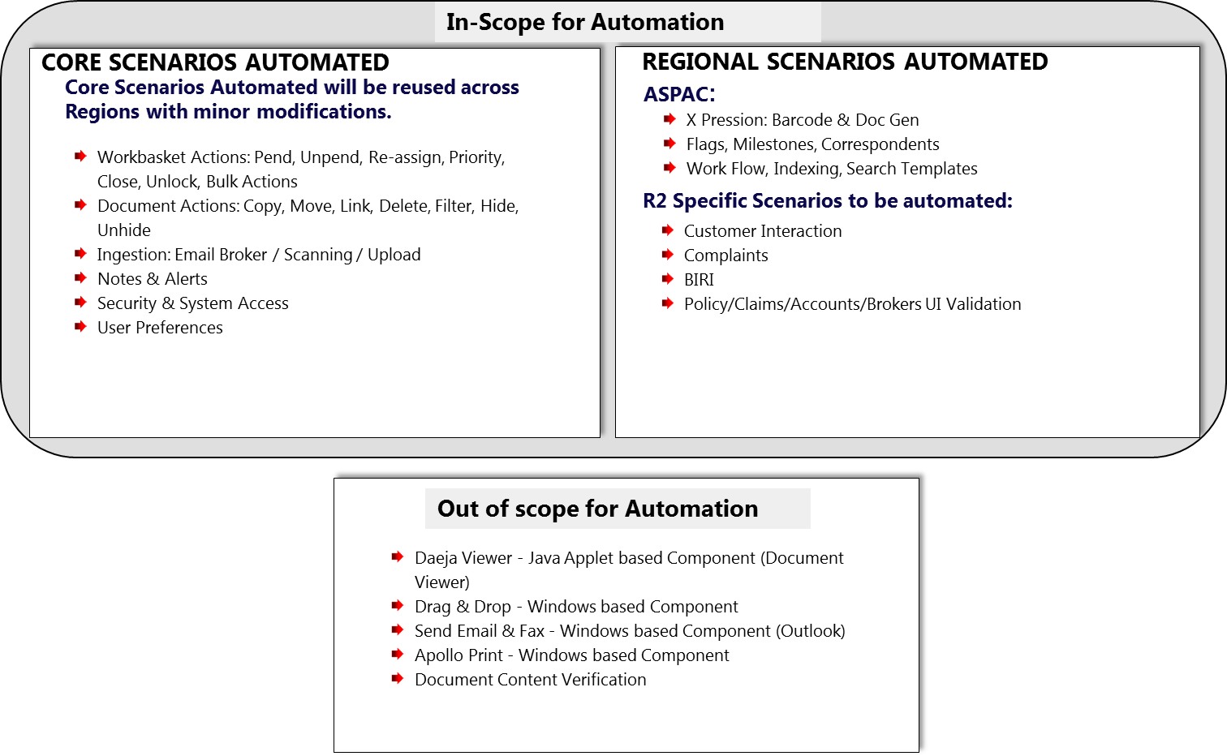

# Overall Test Plan

SIT Build Date

UAT Build Date

Note: Testing timeline is based on the attached build plan.



**Key Highlights – SIT Functional Test Execution:**

* The high level timelines will change based on the build plan shared
* Test Design will be completed by 30th June 2016; Test Execution will commence from mid of June 2016.
* 2 Cycles in each Code Drop; 100% - 1st Cycle and 40% in 2nd Cycle including Defect Retesting. The testing in Cycle 2 with 40% of test cases being executed with an assumption of 30% failure rate in Cycle 1 & 10% regression cases.
* 2 Cycles of testing is planned for each interface for all the regions
* 2 Cycles of End to End Testing are planned for after the completion of SIT and Interface testing.

**Common Best Practices to be leveraged in build / deployment / environment readiness testing:**

* Overall build/Release plan creation & it’s adherence
* Availability of Test environment Co-ordinator and existence of process to plan and monitor the usage and implement the access related requirements.
* Deployment should be planned and max 2 in week to improve the code stability. (Critical defects are exception)
* Build Note is sent for every deployment, it contains testing consideration section filled based on the developer impact analysis

**Interface Test Time Lines:**

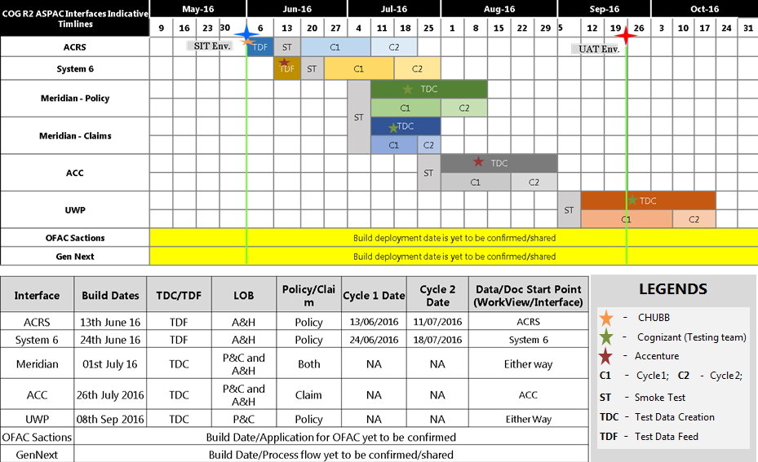

Quality Gates

* Need to achieve the below mentioned test execution pass % in order to start with next test execution cycles,

|  |  |  |
| --- | --- | --- |
| **Test Cases Execution: Pass %** | | |
| **Build Plan** | **Cycle 1** | **Cycle 2** |
| Build 1A - Test Execution | 65% | 80% |
| Build 1B - Test Execution | 65% | 85% |
| End to End - Test Execution | 85% | 90% |
| Regression Testing | 93% | 95% |

* Need to achieve Zero S1 & S2 defects to start with End to End Testing.
* Need to achieve Zero P1 & P2 defects to start with Regression Testing.
* Need to achieve Zero S1, S2, P1 & P2 defects to start with UAT Testing.

# Test Tools

The following table elaborates the different tools that would be used in the course of the Work View Program at different stages of the project life cycle.

|  |  |  |
| --- | --- | --- |
| **Test Tools** | **Test Stage** | **Activities Performed** |
| Microsoft Office Excel 2010 | Test Design | * Preparation of Test Scenarios / Test Cases / Test Conditions * Preparation of Test Data |
| HP - ALM | Test Management | * Test Requirements Creation * Test Design * Requirements Traceability Maintenance * Test Execution * Defect Management |
| IBM Data Studio 4.1.0 | Database / MI Testing | * Data Validations * Reports Testing |
| Notepad ++ | Database / MI Testing | * SQL Query Writing |

# Defect Management

The main intention of Defect Management is to define and implement processes to manage logging and resolution of defects found during any phase of Software Development Life cycle or Software Testing Life Cycle. A well-matured defect management process helps capture proper metrics, which are key indicators for assessing test progress and quality. It also helps in efficient tracking and faster resolution of defects.

## Defect Life Cycle

Defect management will be done by tracking all the defects in the HP ALM. The defect management process will include daily Defect Triage meetings between all stakeholders to perform impact analysis, discuss and categorize the defects.

| **Status** | **Description** |
| --- | --- |
| New | State used when a new defect is first created. Defect has not yet been reviewed by the Business Analyst/Development team |
| Investigation | Validation of a new Issue, or a reopened issue. Business Analyst needs to review the defect and identifies the category of the defect. Coding Issues will be assigned to the Developer and Config. Issues will be sorted out by BA. |
| Fixed | The defect has been fixed, but needs to be verified as fixed through additional testing. Once the fixed is verified, the defect will be moved to SIT environment and the status will be changed to Ready for System Test |
| Ready for System Test | The defect has been fixed by the Development team and is ready to test by System Tester(s). |
| Closed | The Cognizant QA team has reviewed the item and can no longer duplicate it. This is the final status for a defect. |
| Failed Re-test | The defect recurs after the defect has been fixed and is failing while retesting in testing environment |
| Not a fault | The defect that has been raised is not a fault in the System and is considered as a Tester error |
| Deferred | Development has not yet scheduled a release time frame. Defect will not be fixed in the foreseeable future. Defect will remain open, because it needs to be addressed sometime in the life of the product. Deferring of a defect has to be agreed by Cognizant QA, Cognizant & Vega Development teams, CHUBB Management, BA and UAT Team |
| Re-opened | The defect has been successfully resolved but recurs again after sometime |
| Awaiting requirement update | The defect does not require any fix but requires a requirement update. After the requirements are updated, Cognizant QA team to verify the application works as per the updated requirement and will close the defect |
| To be discussed | The defect, which needs discussion with other teams (Cognizant QA team, Development team), is marked as “To be discussed”. After discussion in defect triage and arriving at a consensus, the defect will be moved to investigation |

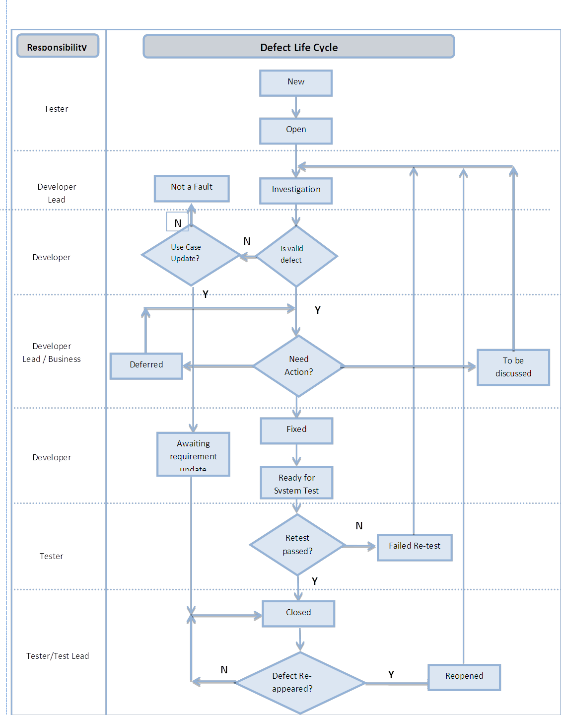

## Defect Triage

The main objective of the defect triage meeting is to keep track of the progress on action of defects. It also serves as a forum to address critical and blocking defects that need immediate attention and defects that need input from business, testing or any other involved teams. As part of the Defect Triage Meeting, a defect is prioritized based on importance and criticality of the business functionality being tested.

Defect Triage meetings will be owned by QA Team and it should include the representations from each team including Development Team and CHUBB Business Analyst

## Defect Classifications

Each defect will be classified by Business Severity (impact on the Business if it is not fixed before implementation) and Fix Priority (impact on Testing). The Fix Priority status will be a driver for defect fixes. The Business Severity and Fix Priority levels are as those selectable in HP ALM.

## Defect Business Severity

| **Severity** | **Description (Business priority regard resolution)** | **SLAs** |
| --- | --- | --- |
| 1 - Critical | The problem causes complete loss of service. Testing cannot reasonably   continue, the operation is mission critical to the business and the situation is an emergency. A Severity 1 problem has one or more of the following characteristics:   * Data corrupted due to which application flow is getting disrupted * A critical functionality is not available. * System hangs indefinitely, causing unacceptable or indefinite delays for resources or response. * System crashes and crashes repeatedly after restart attempts. | Dev Team |
| 2 - High | The problem causes a severe loss of service or functionality failure. No acceptable workaround is available; however, operation can continue in a restricted fashion. | Dev Team |
| 3 - Medium | The problem causes minor loss of service. The impact is an inconvenience, which may require a workaround to restore functionality. | Dev Team |
| 4 - Low | The problem causes no loss of service. The result is a minor error, incorrect behavior, or a documentation error that does not impede the operation of a system. | Dev Team |

## Defect Fix Priority

| **Severity** | **Description** | **SLAs** |
| --- | --- | --- |
| 1 - Critical | Severe impact on the testing plan such that testing cannot continue until a fix is made available. | Dev Team |
| 2 - High | Significant impact on the testing plan with a large number of test cases affected which awaits a fix in order to continue. | Dev Team |
| 3 - Medium | Moderate impact on the testing plan with only one test case affected which awaits a fix in order to continue. | Dev Team |
| 4 - Low | Little / No impact on the testing plan and testing can continue on the test case affected without a fix. | Dev Team |

# Test Data

Test Data preparation approach would vary based on the type of testing involved. Test data will mostly be generated through the entry of test scripts into the systems based on the specific test case requirements by QA Team. The range of test data and conditions will need to adequately ensure that each system function is working correctly to the specification. QA Team to ensure test data reflect the realistic range of business conditions and should, when feasible, test each possible condition.

* Obtain sample real-time data from business team
* Replication of production data from the sources Interfaces
* Test Data (like Invoice copies, mails & fax copies) for Ingestion testing should be provided. It can be reused from ASPAC & NA test data dump after initial analysis
* Production dump of interfacing system is required for test data preparation

Detailed Test Data Requirement is listed in Below Excel



# Test Metrics

Testing Metrics provide pre-defined data upon which progress can be monitored, decisions made and actions taken. Actual metrics are gathered during the test phases, and are used to assess actual progress against planned progress rates.

The following set of metrics will be used to measure progress during different testing phases, the data required to generate metrics below will be sourced from HP ALM primarily.

|  |  |  |  |
| --- | --- | --- | --- |
| **Test Phase** | **Metrics Name** | **Description** | **Measurement** |
| Test Design | Test Design Coverage | Measures functional coverage of the test cases to the requirements | Quality |
| Test Execution | Test Effectiveness | To determine testing effectiveness based on the percentage of defects found prior to UAT | Quality |
| Defect Leakage % (Attributed to Root cause analysis) | Any defect leaked to the next stage indicates that the test / review mechanism for that stage / work product is not adequate. A high leakage rate indicates that the process of review / testing carried out needs to be looked upon. | Quality |
| Error Discovery Rate | Test cases executed/ Total defects found % | Quality |
| Test Case Pass % | % Test Case Executed / Passed | Quality |
| Application Defect Density | The ratio of defects to test cases or the ratio of defects to effort. | Defect |
| Quality of Fixes | To determine how well development team fixed the defects logged by testing team. | Quality |
| Defect Aging | Categorizes & represents the open defects by duration for which they been open so far. | Defect |
| Test Management | % Schedule Variation | This is an indicator to show the capability to meet milestone | On Time Delivery |
| % Effort Variation | This metrics calculates the % of effort deviation from the planned effort. The objective is to reduce the deviation from the estimated effort | On Time Delivery |

# Test Environments

Below is the different type of environments used for Testing:

|  |  |  |  |  |
| --- | --- | --- | --- | --- |
| **Types of Testing** | **Application** | **Environment** | **Region** | **Owner** |
| Functional Testing (SIT, End to End, Regression) | 1. Ignite 2. Genius 3. Classic Apollo 4. Mendix Rating Tool | SIT Environment | United Kingdom | Environment Team |
| UAT | 1. Ignite 2. Genius 3. Classic Apollo 4. Mendix Rating Tool | UAT Environment | United Kingdom | Environment Team |

**Dependency on Environment Team before SIT/UAT**

|  |  |  |
| --- | --- | --- |
| Dependency | Owner | Due Date |
| WorkView SIT Environment Readiness | Environment Team | 1st June 2016 |
| FTP Path Configuration and batch job set for interface schedule batches | Environment Team | 1st June 2016 |
| Integrated SIT environment with following interface SIT instance   * Meridian * UWP * GenNext * ACC * Chubb OFAC Compliance | Environment Team | 1st June 2016 |

# Test Deliverables

Below is the different type of deliverables from Testing:

|  |  |  |  |  |  |
| --- | --- | --- | --- | --- | --- |
| **Phase** | **Deliverables** | **Author** | **Review** | **Sign Off** | **Timelines** |
| Test Initiation / Approach | Unified Test Approach | QA Lead | Cognizant Test Manager | CHUBB Project Manager | End of Test Initiation / Approach Phase |
| Requirement Analysis & Test Planning | Test Plan | QA Lead | Cognizant Test Manager | CHUBB Project Manager | End of RA & Test Planning Phase |
| Requirement Analysis & Test Planning | Baseline Estimates | QA Lead | Cognizant Test Manager | CHUBB Project Manager | End of RA & Test Planning Phase |
| Requirement Analysis & Test Planning | RTM | QA Analysts | Cognizant Test Manager | CHUBB Project Manager | End of RA & Test Planning Phase |
| Test Design | Test Scenario | QA Analysts | CHUBB BA Team  Cognizant QA Lead | CHUBB BA Team | Refer the detailed plan in the timeline section |
| Test Design | Test Cases / Test Data | QA Analysts | CHUBB BA Team  Cognizant QA Lead | CHUBB BA Team | Refer the detailed plan in the timeline section |
| Test Execution | Test Execution Reports | QA Lead | CHUBB BA Team  Cognizant Test Manager | Not Applicable | Weekly |
| Test Execution | Defect Logs | QA Lead | CHUBB BA Team  Cognizant Test Manager | Not Applicable | Weekly Twice |
| Test Execution | Business Readiness Dashboard | QA Lead | CHUBB BA Team  Cognizant Test Manager | CHUBB Project Manager | End of Test Execution phase |
| Test Closure | Executive Test Summary Report | QA Manager | CHUBB Project Manager | CHUBB Project Manager | End of Test Closure Phase |
| Test Closure | Release Retrospection | QA Lead | CHUBB BA Team  Cognizant Test Manager | CHUBB Project Manager | Weekly |
| Test Closure | GO-NO GO Recommendations | QA Manager | CHUBB Project Manager | CHUBB Project Manager | End of Test Closure Phase |

# Test Criteria

## Test Entry / Exit Criteria

|  |  |  |
| --- | --- | --- |
| Test Phase | Entry Criteria | Exit Criteria |
| Test Design | * Requirements (BRD, SAS) base-lined and signed off by the Business * Availability of SMEs and BAs for Requirements walkthrough and resolving Queries | * Test Coverage 100% Reviewed and Signed Off * Test Scenarios Reviewed and Signed off * Requirement Traceability Completed * Test Cases Uploaded and available in HP ALM |
| Smoke Testing | * Successful completion of Unit Testing by the Development team with Pass percentage of 90% * Successful completion of Build deployment to SIT environment and accessible from VDI. * Release Notes shared with QA Team * No critical priority issues / defects outstanding from Integration testing * Work View should be installed in QA VDI * Interface Systems should be integrated with Work View * Availability of Test Users, Data in Reference DB | * 100% Smoke Test Suite Completion * Pass Percentage of 90% |
| System Integration Testing | * Successful completion of Sanity Testing * All test Cases are reviewed and Signed off * All test cases is uploaded and available in Test lab for execution * All Tester have access to HP ALM | * 100% of all severity 1&2 defects should be resolved or agreed to be open by the BA team * 100% Test execution coverage of all must and should features * Test Execution has achieved 95% and Pass Rate 85% * Identified Regression test cases should be executed * Test Completion Report should be delivered and signed off |
| End to End Testing | * Successful completion of SIT * All test Cases are reviewed and Signed off * All test cases is uploaded and available in Test lab for execution | * 100% of all severity 1&2 defects should be resolved or agreed to be open by the BA team * 100% Test execution coverage of all must and should features * Test Execution has achieved overall 90% Pass Rate * Identified Regression test cases should be executed * All Critical, High or Medium defects should be fixed and retested. * Non fixed defects should be deferred for future releases based on the defect prioritization by Business. |

## Test Suspension / Resumption

|  |  |
| --- | --- |
| Suspension Criteria | Resumption Requirements |
| Non-availability of the application | Availability of the application |
| Show stopping defects, which prevent further testing along all path and no further testing can be proceeded | Show stopper is rectified |
| All the possible test cases have been tested with the failure notified and the fixes for the same have not arrived for re-testing. | Arrival of build with fixed defects |
| Defect Leakage / Recurrence in subsequent rounds of testing | Proper rectification of defects |
| Testing Environment is not ready or set up properly | Proper availability of Test environment |
| Defect discovery rate more than 60% | Rectification of defects which opens up majority of test cases |

## Test Assumptions / Dependencies

**Assumptions:**

* Test plans/ Approach will be reviewed and agreed by SME’s , BA’s and EA’s
* BA team will provide the signed off Use cases before the start of Test Design. Any delay will impact overall schedule of the project.
* BA or Program Manager to provide sign-off for test scenarios before the execution to baseline on agreed date as per the project plan
* Timely clarification of requirements ambiguities during test design phase.
* Any further change requested to be handled through the change management process based on the impact
* All builds are delivered with 100% functionality as per schedule.
* QA environment to be available with all required hardware, software and configurations one day before the start of test execution
* QA environment to be available >90% of the time during test execution timeframe
* Unit testing will have successfully completed on all items to be tested in SIT
* Developer support will be available throughout the testing phase
* CHUBB SME’s/BA’s will be available throughout the testing phase.
* The Dev Team will integrate dependent systems before the start of the execution.
* Test environment mimicking production environment in terms of configuration of apps, availability of apps (for UAT and E2E Testing), data volume (for Performance Testing) and data integrity for integration/ end-to-end testing.

**Dependencies:**

* Testers will have completed training in advance of the testing start date.
* Should have access for dependent systems/Interfaces.
* Support from CHUBB BA for timely clarification of requirements ambiguities during test design phase & to update Query Tracker in CHUBB SharePoint folder.
* QA deploy should be done on the planned delivery date. Delay in code drops will affect quality of the applications (regression defects).
* Dedicated test environment manager and existence of process to plan and monitor the usage and implement the access related requirements.
* Need to define a process to determine the requirement freeze date (after which we requirement change will go in through CR process and revised estimate would be submitted).
* Support is required from third party providers (IBM- Daeja Viewer) for defect resolution.
* Need developer/IT Ops team support to run batch jobs.
* Any unplanned downtime of the Interfaces should be notified well ahead to QA.
* Roadblock defects (Application and Environmental Issues) to be fixed within 4-7 hours on communication.
* Quality of fix should be >80%.

# Roles & Responsibilities

The following table defines the roles and responsibilities of the key stake holders in testing.

|  |  |
| --- | --- |
| **Role** | **Responsibilities** |
| CHUBB Project Manager | * Provide support to ensure the testing effort is successful * Manage and communicate project status and change control * Coordinate Review and Sign off Test Plan * Coordinate Review and Sign off Test Cases * Review and Sign off on Test Summary Report |
| CHUBB Business Analyst | * Provide KT to the Test Analysts (if required) * Provide support on resolving clarifications raised by Testing team * Review and Sign off on high level and detailed test cases |
| Test Manager | * Responsible for overall testing delivery of the project * Review and approve all major testing deliverables * Work with CHUBB Project Manager to evaluate and implement changes to the project testing scope, testing approach and/or testing schedule * Create / Update / Maintain Project Plan * Participate in management reviews and teleconferences * Provide identified issues to CHUBB Project Manager to be encapsulated as lesson learnt post-implementation * Provide or report on overall status of testing as needed * Maintain the Test Plan and ensure adherence to it during the entire testing project |
| Onsite Test Lead | * Status reporting to CHUBB Program Manager * Establish a central area for logging and tracking issues and defects until resolved or prioritized with a future date (if applicable). To be determined by CHUBB Program Manager * Communicate status of overall test results to CHUBB Program Manager by the testing phase in progress * Single point of contact for all project related queries and ensure clarifications are provided on a timely basis * Prepare milestone document and detailed project plan * Participate in the requirements design review * Analyze and report requirements coverage * Coordinate test case design * Coordinate test data preparation/generation * Report defects according to the defined process * Coordinate the overall project testing effort * Manage the defect tracking / reporting process * Coordinate onsite and offshore testing efforts * Work allocation and Status reporting |
| Offshore Testing Team | * Review and validate requirement specification * Design Test Scenarios * Design Test Cases and Peer Review * Prepare Test Data and Peer Review * Coordinate Test Case Execution * Report defects according to the defined process * Manage the defect tracking / reporting process * Metrics Collection |

# RACI Matrix

The following RACI (Responsible, Accountable, Consulted, and Informed) matrix captures the role of different stake holders of this project across stages/activities related to Testing.

|  |  |  |  |  |  |  |  |
| --- | --- | --- | --- | --- | --- | --- | --- |
| **Phases** | **Activity** | **Cognizant** | | | | **CHUBB** | |
| Delivery Manager | Test Manager | Test Lead | Test Analyst | Program Manager | Business Analyst |
| Test Requirement Analysis | Study Functional Specification and Business Requirements Documents | I | A | R | R | I | C |
| Conduct Requirement Ambiguity Clarifications Sessions | I | A | R | C | I | C |
| Test Design | Prepare Test Conditions | I | A | R | R |  | C |
| Prepare Test Cases / Test Data | I | A | R | R | I | C |
| Identify Smoke Test Cases | I | A | R | R | I | C |
| Review and Sign off Test Conditions / Scenarios | I | I | A | R | I | C,R |
| Test Execution | Execute Test Cases / Test Scripts | I | A | R | R | I | C |
| Conduct Defect Triage Meetings | I | A, I | R | C | I | C |
| Prepare and Publish Test Metrics Report to the project management team | I | A | R | R | I |  |
| Support UAT Test Execution (If applicable) | I | A | R | R | I | C |
| Review UAT Defects (If applicable) | I | I | C | C | I | C |
| Review Outstanding Defects and Obtain Business Approval | I | A | R |  | I | C |
| Test Closure and Production Checkout | Prepare / Refine end of Test Summary Report | I | A | R | C | I |  |
| Execute Production Checkout Test Cases / Test Scripts | I | I | A | R | I | C |
| Publish Functional Test Summary Report to the project management team | I | A | R | C | I |  |

# Reference Documents

**Functional Requirements**

[http://europespace.acegroup.com/sites/AR_AOGRel3_Project/SitePages/Home.aspx?RootFolder=%2Fsites%2FAR%5FAOGRel3%5FProject%2FShared%20Documents%2F03%5FFunctional%5FDesign%2F07%20Functional%20Requirements&FolderCTID=0x012000A94F981F8FF08D40A56C72D5EAD2B984&View={53B4DA14-BE86-4765-BF10-40864446FE75](http://europespace.acegroup.com/sites/AR_AOGRel3_Project/SitePages/Home.aspx?RootFolder=%2Fsites%2FAR%5FAOGRel3%5FProject%2FShared%20Documents%2F03%5FFunctional%5FDesign%2F07%20Functional%20Requirements&FolderCTID=0x012000A94F981F8FF08D40A56C72D5EAD2B984&View=%7b53B4DA14-BE86-4765-BF10-40864446FE75)

**Claim Functional Spec**

[http://europespace.acegroup.com/sites/AR_AOGRel3_Project/SitePages/Home.aspx?RootFolder=%2Fsites%2FAR%5FAOGRel3%5FProject%2FShared%20Documents%2F03%5FFunctional%5FDesign%2F03%20Claims&FolderCTID=0x012000A94F981F8FF08D40A56C72D5EAD2B984&View={53B4DA14-BE86-4765-BF10-40864446FE75](http://europespace.acegroup.com/sites/AR_AOGRel3_Project/SitePages/Home.aspx?RootFolder=/sites/AR_AOGRel3_Project/Shared%20Documents/03_Functional_Design/03%20Claims&FolderCTID=0x012000A94F981F8FF08D40A56C72D5EAD2B984&View=%7b53B4DA14-BE86-4765-BF10-40864446FE75%7d)

**Customer Interaction spec document**

[http://europespace.acegroup.com/sites/AR_AOGRel3_Project/SitePages/Home.aspx?RootFolder=%2Fsites%2FAR%5FAOGRel3%5FProject%2FShared%20Documents%2F03%5FFunctional%5FDesign%2F05%20Customer%20Interaction&FolderCTID=0x012000A94F981F8FF08D40A56C72D5EAD2B984&View={53B4DA14-BE86-4765-BF10-40864446FE75}](http://europespace.acegroup.com/sites/AR_AOGRel3_Project/SitePages/Home.aspx?RootFolder=/sites/AR_AOGRel3_Project/Shared%20Documents/03_Functional_Design/05%20Customer%20Interaction&FolderCTID=0x012000A94F981F8FF08D40A56C72D5EAD2B984&View=%7b53B4DA14-BE86-4765-BF10-40864446FE75%7d)

**Complaints Functional Spec**

[http://europespace.acegroup.com/sites/AR_AOGRel3_Project/SitePages/Home.aspx?RootFolder=%2Fsites%2FAR%5FAOGRel3%5FProject%2FShared%20Documents%2F03%5FFunctional%5FDesign%2F06%20Complaints&FolderCTID=0x012000A94F981F8FF08D40A56C72D5EAD2B984&View={53B4DA14-BE86-4765-BF10-40864446FE75}](http://europespace.acegroup.com/sites/AR_AOGRel3_Project/SitePages/Home.aspx?RootFolder=/sites/AR_AOGRel3_Project/Shared%20Documents/03_Functional_Design/06%20Complaints&FolderCTID=0x012000A94F981F8FF08D40A56C72D5EAD2B984&View=%7b53B4DA14-BE86-4765-BF10-40864446FE75%7d)

**Interfaces Link**

[https://officespace.ace-ina.com/s/Apollo2Symposium/General/Forms/AllItems.aspx?RootFolder=%2Fs%2FApollo2Symposium%2FGeneral%2FApollo%20Refresh%20Program%2F07%5FRelease%5F2%2F12%5FInterface%5FAnalysis&FolderCTID=0x012000B7F9EC70C9752B4DA37DF18AA4F04B81&View=%7B63698F83%2DC9C8%2D44F4%2DA5E9%2D560C9C24594E%7D](https://officespace.ace-ina.com/s/Apollo2Symposium/General/Forms/AllItems.aspx?RootFolder=/s/Apollo2Symposium/General/Apollo%20Refresh%20Program/07_Release_2/12_Interface_Analysis&FolderCTID=0x012000B7F9EC70C9752B4DA37DF18AA4F04B81&View=%7b63698F83-C9C8-44F4-A5E9-560C9C24594E%7d)